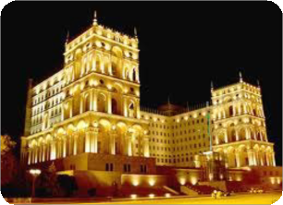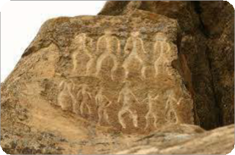

8 DAYS BAKU-SHEMAKHA-SHEKI-GUBA TOUR ITINERARY:

Day 1 - Baku - Arrival Day
Upon arrival, meet with our local representative in the airport. We will transfer you to your hotel for checking in and settle down and you will be given your room key.
Dinner and overnight in Baku.

Day 2 - Baku Old City Tour
(Breakfast included)
After your breakfast in your hotel, we shall start our city tour today. We will visit the old city - Icheri Sheher, as know as Inner city. It is the historical core of Baku. For a long period of time, an explicit symbol of the Old City was a mulberry tree located behind the Djuma Mosque. It was believed that the tree was several hundred years old. The tree made its way into many sayings and songs popular in the Old City, and became a local landmark. The place where that tree was located was referred to as Mulberry Tree Square. However, in 1970s the mulberry tree was cut down, because of the nearby construction works.

In the city, we will visit Palace of the Shirvanshahs which is the
biggest monument of the Shirvan-Absheron branch of the Azerbaijan architecture. Also we will viist the Maiden Tower which is noted landmark and one of Azerbaijan's most distinctive national emblems. In December 2000, both of them became the first location in Azerbaijan to be classified as a World Heritage Site by UNESCO.
Overnight in Baku

Day 3 - Baku
Breakfast
This day is devoted for visiting to Gobustan reserve. Gobustan is an open-air museum with littered Neolithic rock drawings. Just 65km in the South of Baku, Gobustan has some 4000 inscriptions that go back 12,000 years (with some 2000 year old Latin graffiti to
boot). You can see a lot of drawings made by Stone Age folks on
the rocks, which reflect the daily life, especially as they were hunting and liked boogie. Their dances are thought to have been accompanied by the melodious strains of the Gaval-Dashy (Tambourine Stone) - a rock that has a deep, resonating tone when struck. The well-preserved sketches display ancient

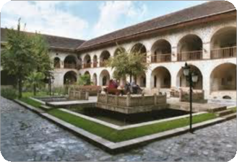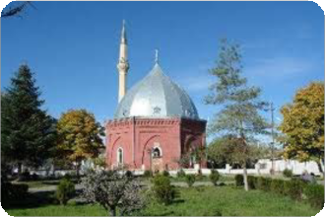
populations travelling on reed boats; men hunt antelope and wild bulls, women dance. The famed Norwegian anthropologist Thor Heyerdahl returned many times to Azerbaijan between 1961 and his death in 2002 to study the site, which he argued to be evidence that modern-day Scandinavians migrated north through the Caucasus in prehistoric times. He found similarities in the drawings to those found in Scandinavia, particularly some in Alta, Norway. According to Icelandic Sagas, written in the 13-th century, the Norse God Odin (Wotan) migrated from the Caucasus in the first century AD.
Overnight in Baku

Day 4 Baku - Shemakha - Sheki
(Breakfast included)
Breakfast in Hotel
Then we go to Sheki. En-route stop by active mud volcanoes plateau at 41st km of the highway. On our way, we will stop in Maraza to visit the Diri Baba mausoleum and visit Seven Tombs and Friday mosque in Shemakha.
Upon arrival Sheki, we will visit Local history museum, local applied arts museum and Shebeke craft centre and showroom. At the end of the tour,
transfer to your hotel and check in . Dinner and overnight in Sheki.

Day 5 - Sheki – Kish - Baku
(Breakfast included)
After breakfast, we will go to walk through the Sheki bazaar and look at the various local handicrafts including scarves, unique boxes, a plethora of sweets, confections and local sweet bakery. Then we will visit to Palace of Sheki Khans (XVIII A.D.) where is the most outstanding and valuable monument of the 18th century Azerbaijan
, church in the village Kish( I c.).
At then end, transfer you to the
Arrival Baku. Overnight in Hotel in Baku

Day 6 – Baku – Guba
Breakfast in Hotel.
After breakfast our trip is continued to Guba region the North part of Azerbaijan. On the way to see Sumgait city – the third big city of Azerbaijan, to see Besh Barmag (five fingers )mountain. In Guba town to see Juma Mosque, Lunch
After lunch visit to Red Settlement of Jewish.
Overnight in Hotel in Guba

Day 7 – Guba (Red Avenue) – Baku
Breakfast in Hotel.
After breakfast Return to Baku. On the way visit to “Cemetry Guba” Arrival to Baku
Overnight in Baku

Day 8
Transfer to Airport (Haydar Aliyev)

8 DAYS BAKU-SHEMAKHA-SHEKI-GUBA TOUR INCLUDES:

• Airport – Hotel – Airport transfer
• 5 nights BB accommodation 4* Hotel in Baku
• 1 night BB accommodation Hotel in Sheki
• 1 night BB accommodation 4* Hotel in Guba
• Professional English-Speaking guide during Tour
• All entrance fees for all museums mentioned in the itinerary
• Entrance fee
• Transportation in a fully air-conditioned, non-smoking private coach

In DBL room (2 persons in group) | 1064 EUR
İn SNG room (2 persons in group) | 1278 EUR
In DBL room (6 persons in group) | 670 EUR
İn SNG room (6 persons in group) | 890 EUR
In DBL room (10 persons in group) | 585 EUR
İn SNG room (10 persons in group) | 800 EUR

